Week 1

* Exam week, all my time was spent revising for exams and final touches to Physical computing project

Week 2

* Exam week, all my time was spent revising. Need to test if idea is feasible before compliance statement deadline.

Week 3

* After fully testing my idea, I realised that there is major flaw with the braille reader. When the user presses down on the braille dot, the force will push the braille dot down. Simply, put it the design could not support a user’s finger, a non-accessible industrial manufacturing mand material would be required.
* I have noticed that the assembly programming knowledge among programmers and students is rare and almost non-existent
* I am going to do a crash course in assembly language for ARM and intel processors
* What if there was a way to program assembly in 3D?

Week 4

* I’ve ironed out my new concept

Braylya: a FPS boss-battler where braille code is your weapon.

Motivation:

There is no modern game that teaches braille code to players. Sighted teachers are needed to teach braille to blind people. Through my talks with many different people, with my previous braille project there is almost no understanding of braille systems, many people do not know if they exist. There needs to be much needed attention about braille and literacy among the blind.

Learning braille using modern gaming mechanisms and environment.

The beauty of braille is that all human languages on earth can represented in just 6 to 8 dots. Game will focus on UEB (Unified English Braille) as proof of concept.

<https://www.pharmabraille.com/braille-codes/unified-english-braille-ueb-code/>

Game Concept:

* Giant boss controlled by AI. Mech design. Boss represents English language; periodically changing English letters are placed all over the bosses’ body.
* Player is humanoid. Player has a special gun that is configured by braille alphabets, its projectiles can only damage a certain part of the bosses’ body if the braille code entered on the gun matches the English letter on the bosses’ body. Players press a button to slow down time (Q) which gives them time to enter a braille code using 6 buttons from the keyboard, they can now shoot their gun at the correct English letter to damage the boss.
* For example, the bosses arm has letter A on it. Player would press the Q key to slow time, the enter the letter A in braille which is 1 in braille dot notation, user presses the key 1. (number keys represent braille dot notation), if user now fires the gun at the arm the bosses health will decrease. = successful hit
* Player also has special limited ability to reveal the correct braille codes on the bosses’ body, this is to assist learning braille, forces player to learn braille on the spot. Special ability is recharged via successful hits against monster.
* Player can move around fast and jump high, use a jetpack, the boss attacks are fast and varied. Player only regenerates health from a successful hit against boss. Player learns braille first and learns the patterns in braille.
* Boss is defeated when the boss’s health bar is depleted. The next arena is unlocked. Each arena has a different boss, each boss represents a different braille code system. First boss = UEB, second boss = Arabic braille, third boss = Russian Braille.

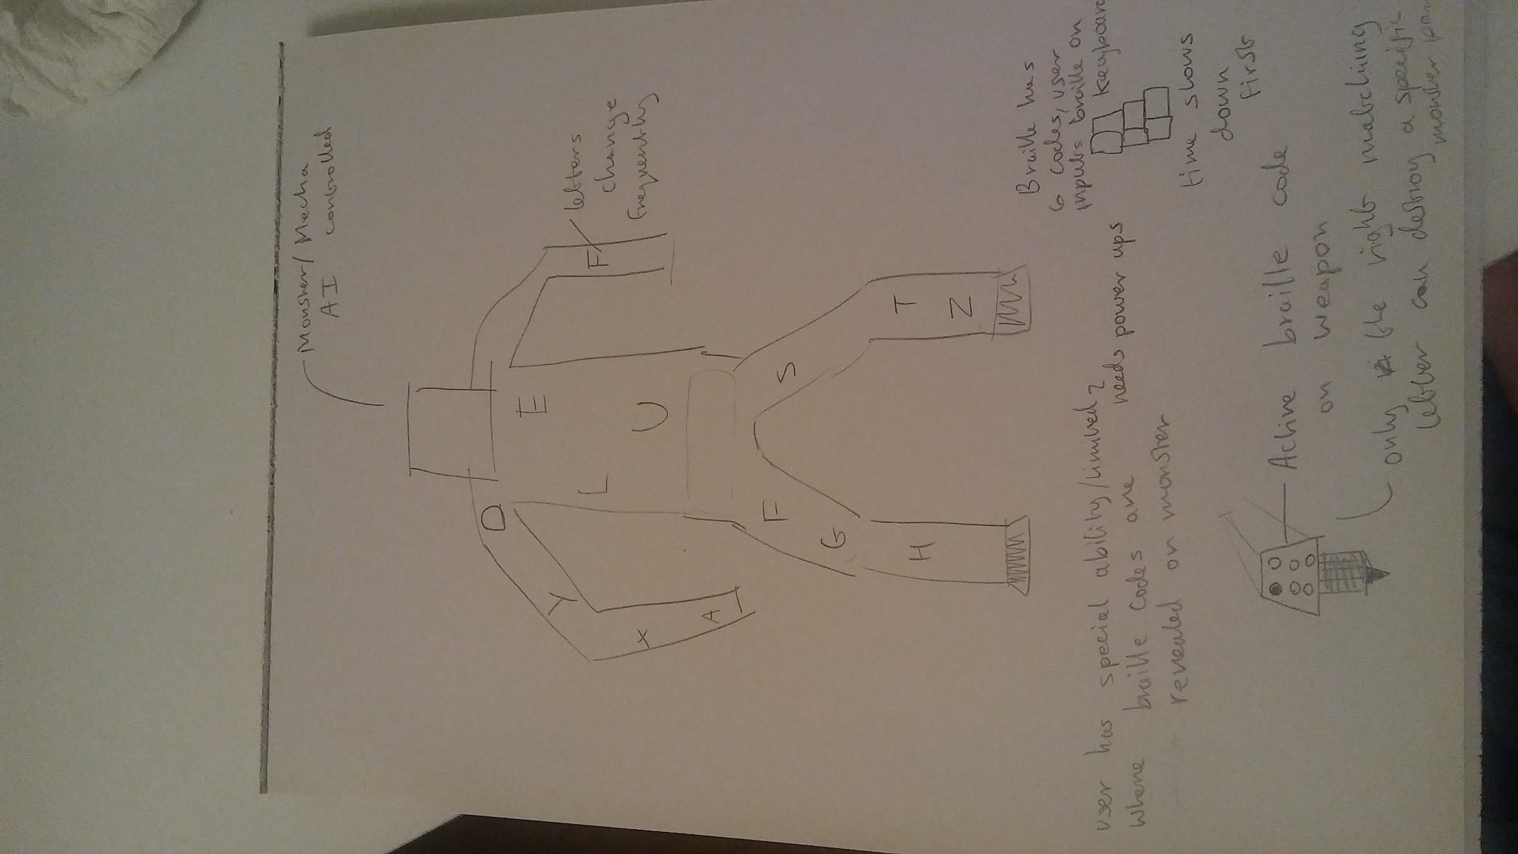

Assets:

All assets needed for 3d models and base template will be from the Unity FPS sample <https://github.com/Unity-Technologies/FPSSample> license allows me to reuse and modify project. I just need to modify the assets and code this unique gameplay mechanic.

<https://www.youtube.com/watch?v=-y0YiQ_pSsw>

Plan:

* Need to get FPS sample up and running. Turns out FPS sample is too complex for my needs. Need to find an asset pack that is more simpler.
* Focus on gameplay mechanic first, using props.
* Aesthetic detail can be added later after gameplay mechanic is working.

I Have found a very good asset sample to build on top of, it’s the Unreal engine FPS sample, works very well so far unlike the problems the unity engine gave me. Unreal engine has a steeper learning curve but with the high quality free assets (3d models) available with the unreal engine, I think it is worth it.